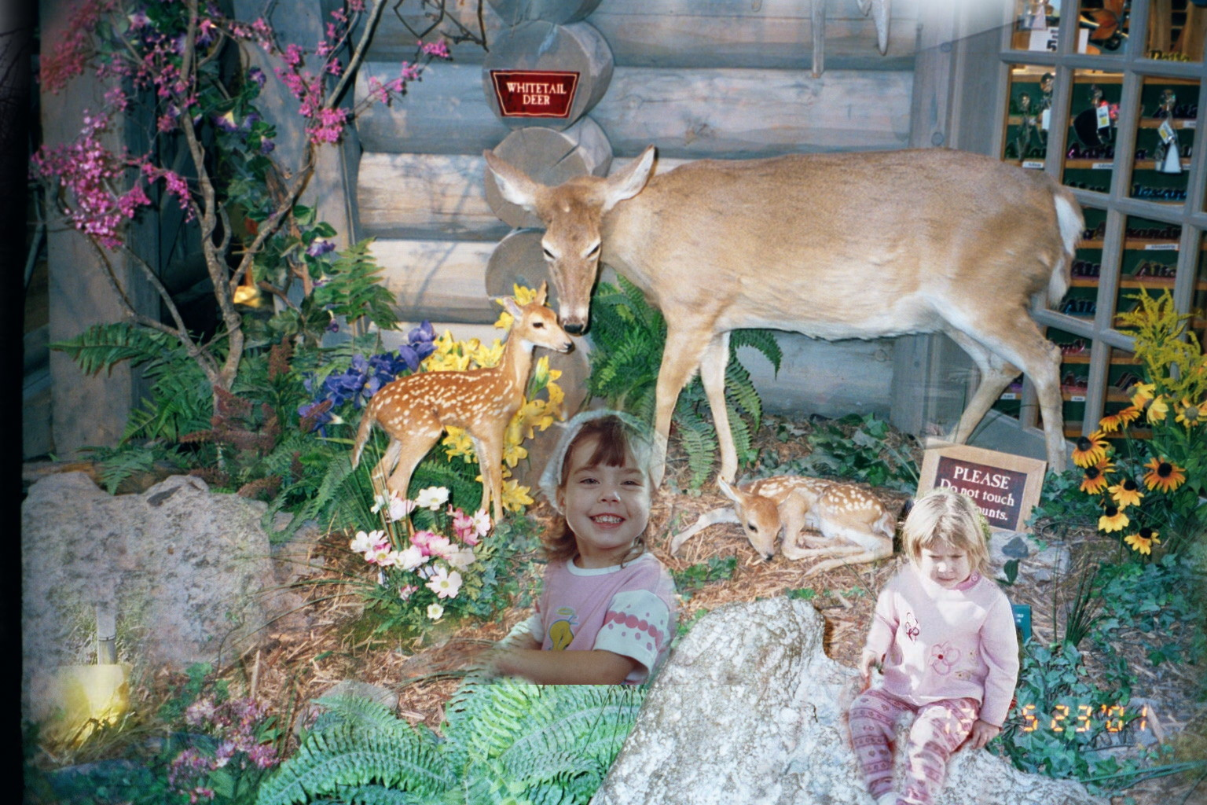
Created by: Cindy Mullins Cinthia is the one with bandana on DeeDee is sitting next to Do Not Touch Sign.
Cinthia is Amy and David Hyatt’s Daughter
Dakota is Teresa And Gary Tague’s Daughter

