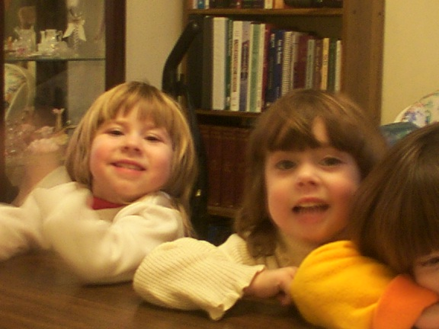Created by: Cindy Mullins Cinthia,Dakota,& Half of Chy
Cinthia is Amy and David Hyatt’s Daughter
Dakota & Cheyenne are Teresa And Gary Tague’s Daughters

